Travel Plan Itinerary Generator

In propose work we are employing Deep Learning AI models to generate itinerary and then employing Web Scraping technique to download images related to generate itinerary and then employing RAG algorithm to search and select itinerary which is best match with user requirements based on hotels, flights, weather condition and many more criteria.

To implement this project we have designed following modules

1. User Sign up: user can sign up with the application
2. User Login: user can login to system
3. Generate Travel Plan: using this module user will enter source, destination, budget and some description related to weather, food, flights etc. Application will generate itinerary as per user criteria and then employ RAG model to select itinerary based on user input and then scrape web to download best images from selected itinerary.

Below code using to search itinerary using RAG

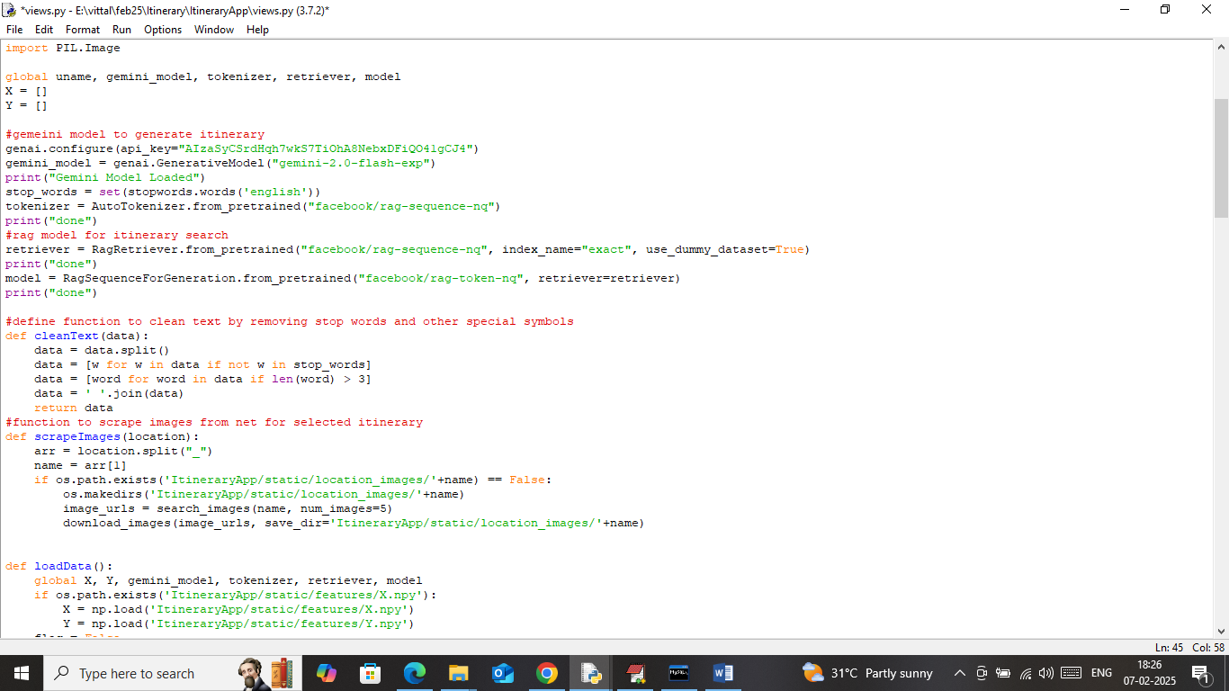

In above screen read red colour comments to know about all technologies you asked for.

To run project install python 3.10 and then install all packages given in requirements.txt file and then copy content from ‘database.txt’ file and paste in MYSQL console to create database. Now double click on ‘run.bat’ file to start python server and get below page

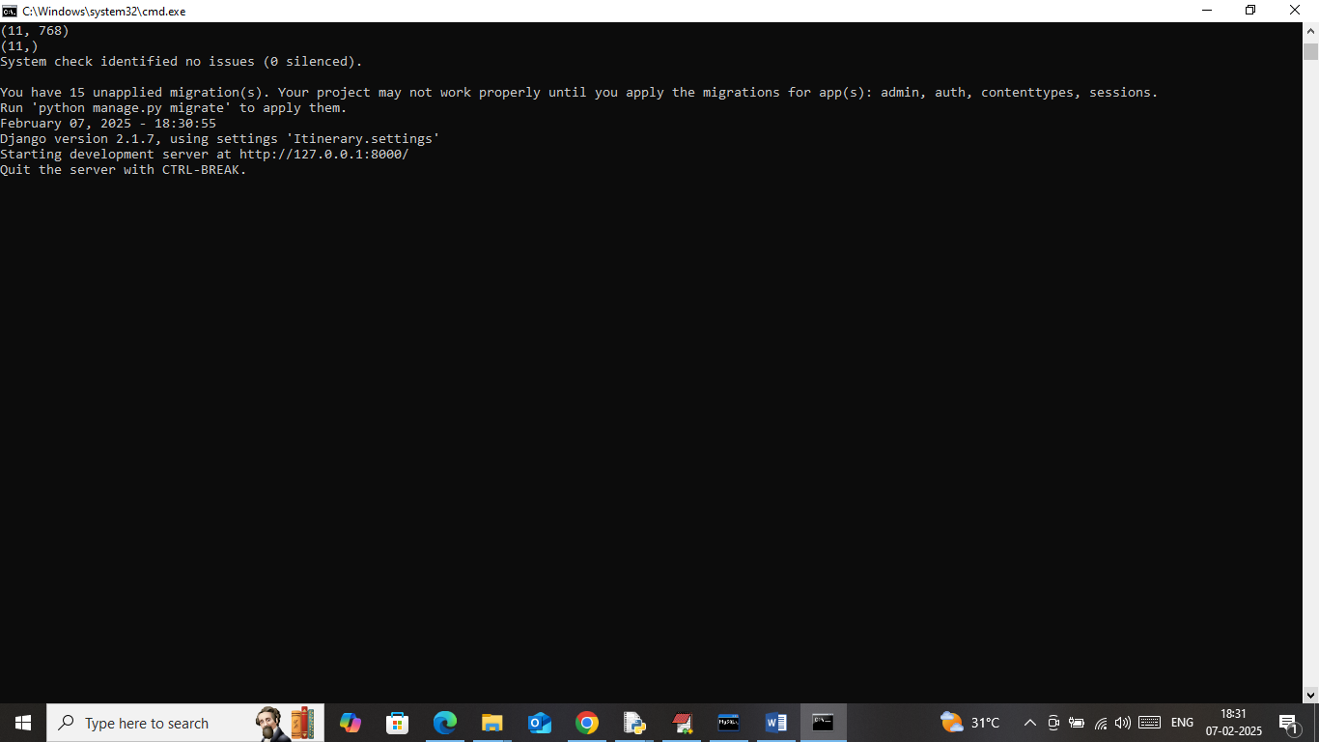

In above screen python server started and now open browser and enter URL as <http://127.0.0.1:8000/index.html> and then press enter key to get below page

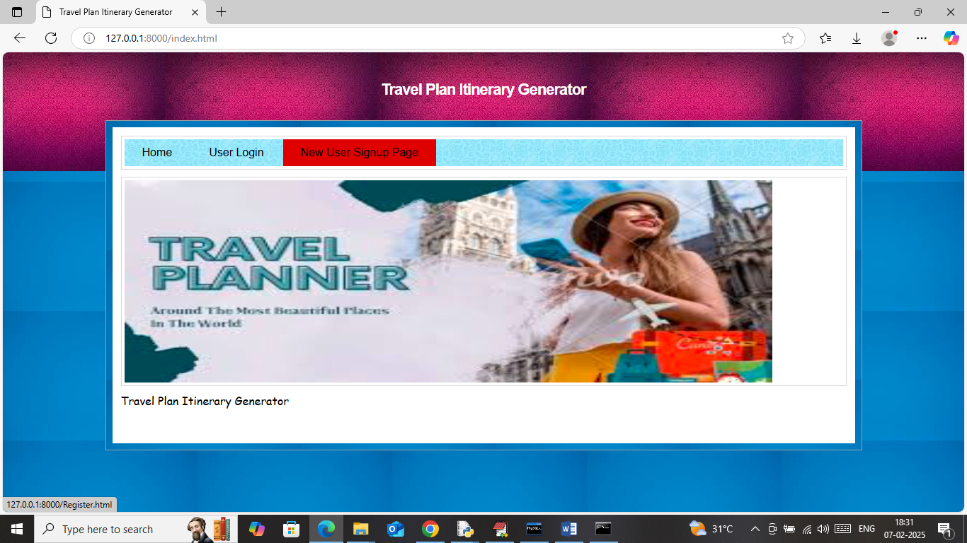

In above screen click on ‘New User Sign up’ link to get below page

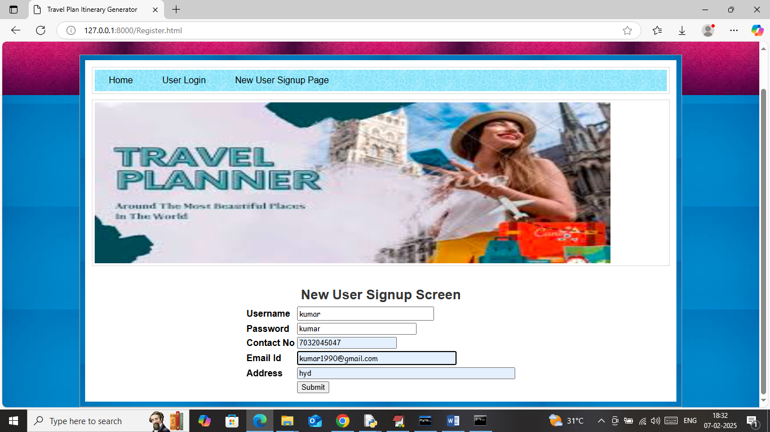

In above screen user is entering sign up data and then press button to get below page

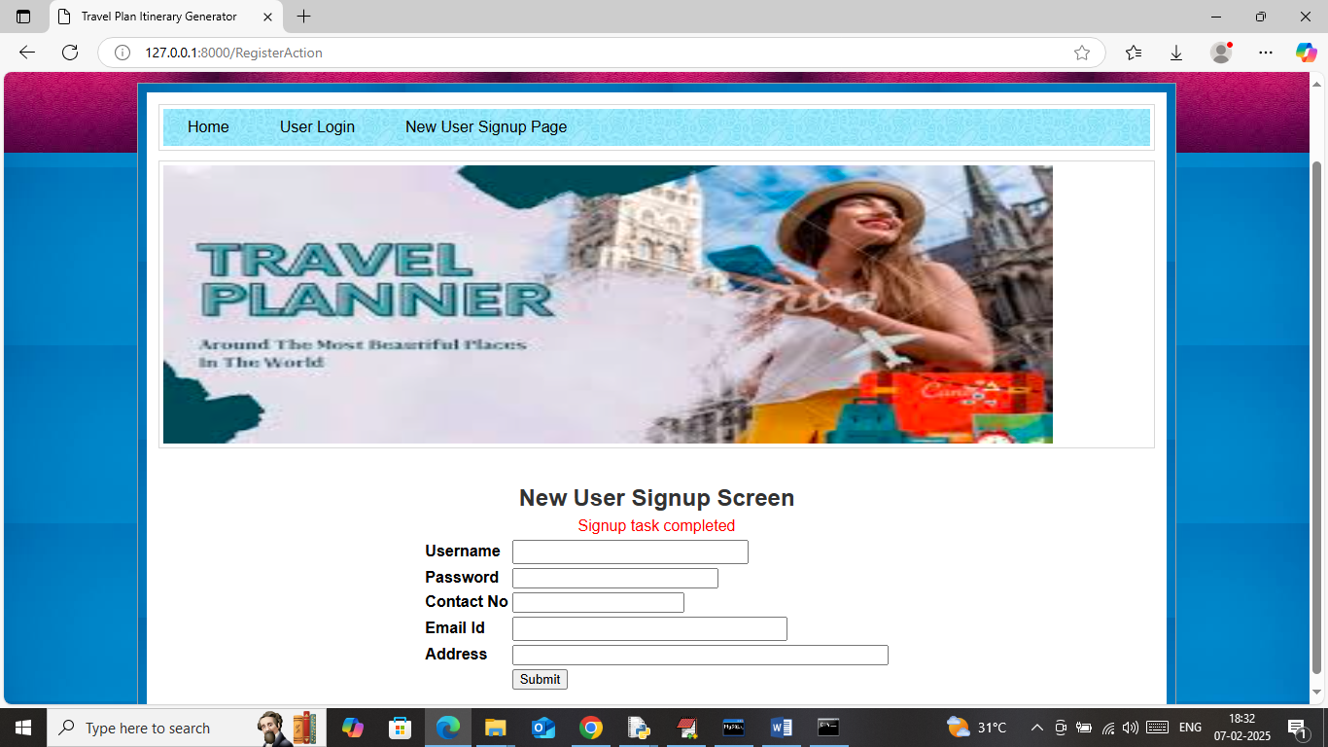

In above screen sign up task completed and now click on ‘User Login’ link to get below page

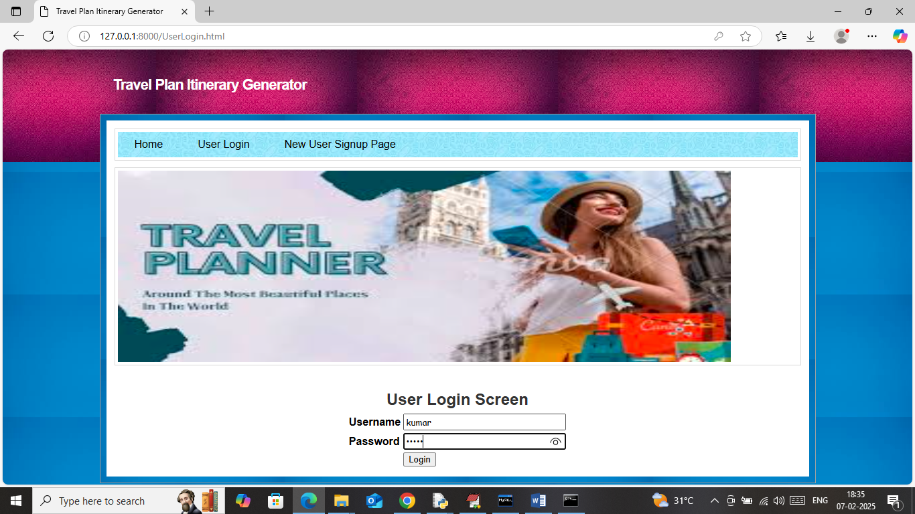

In above screen user is login and after login will get below page

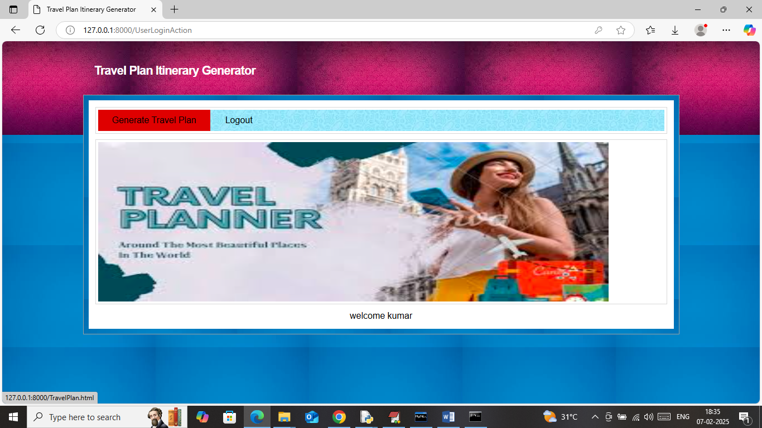

In above screen click on ‘Generate Travel Plan’ link to get below page

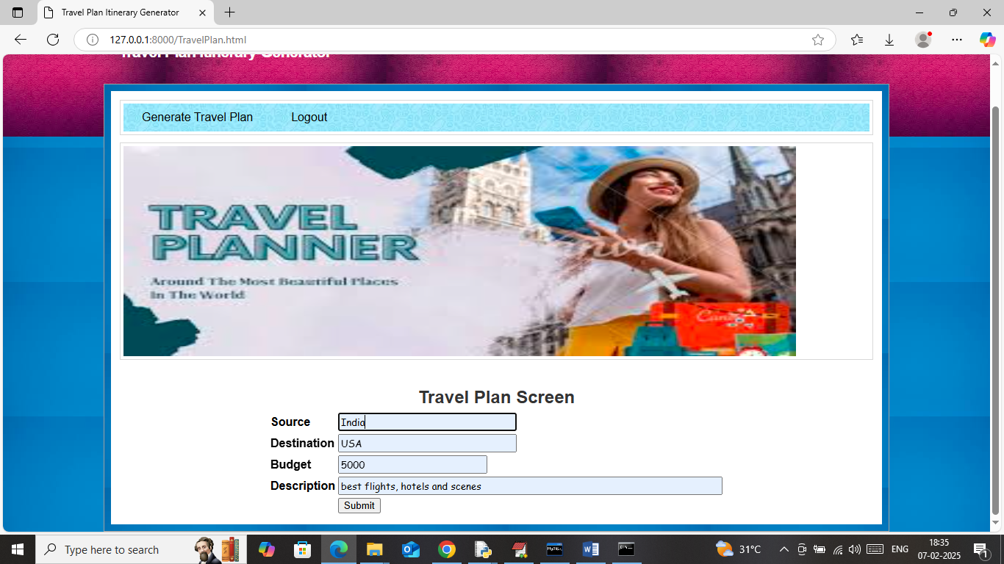

In above screen I am entering source, destination and other details and then press button to get below page

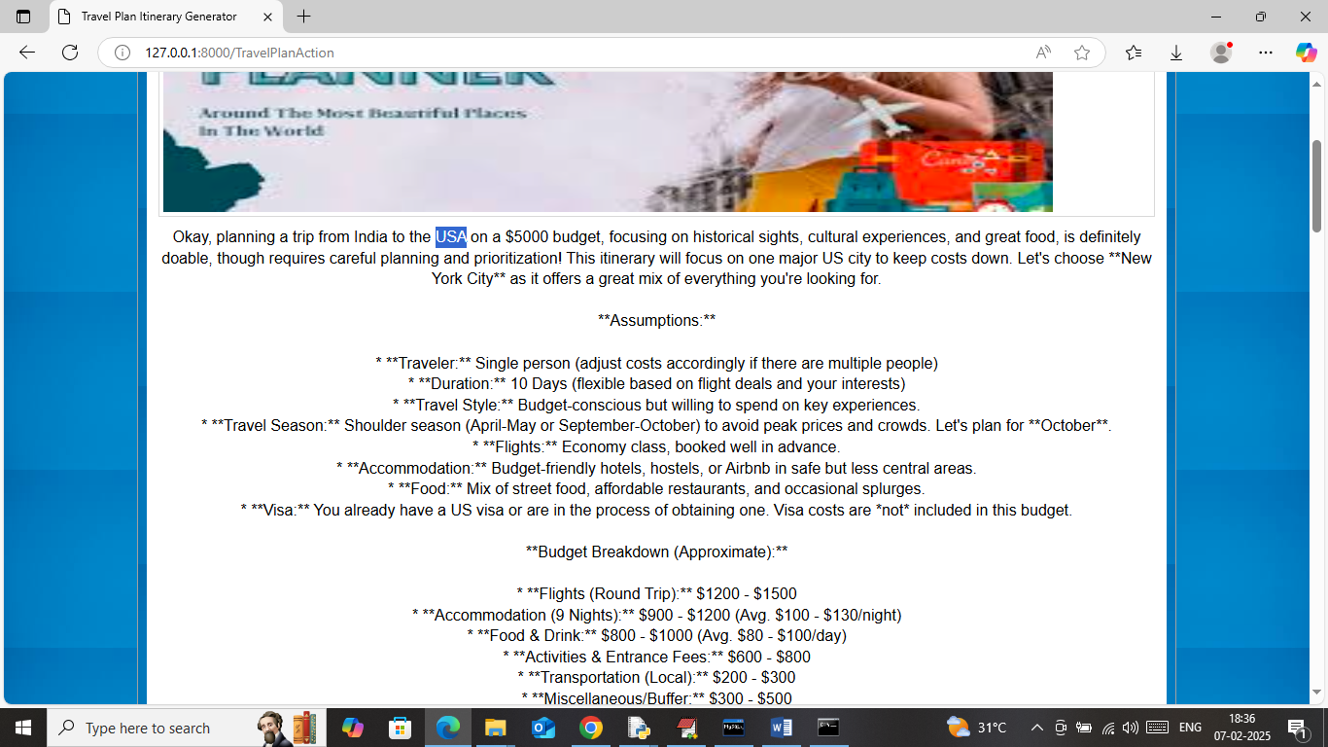

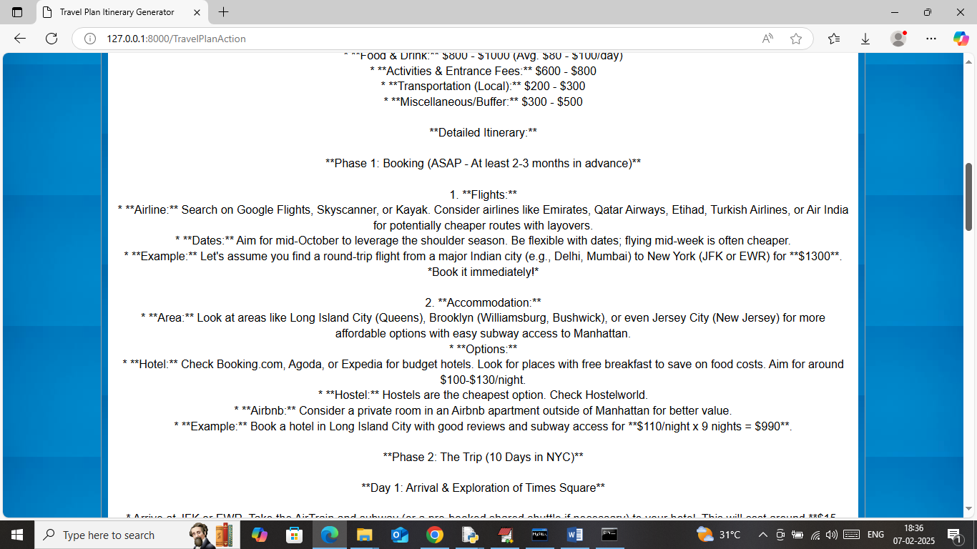

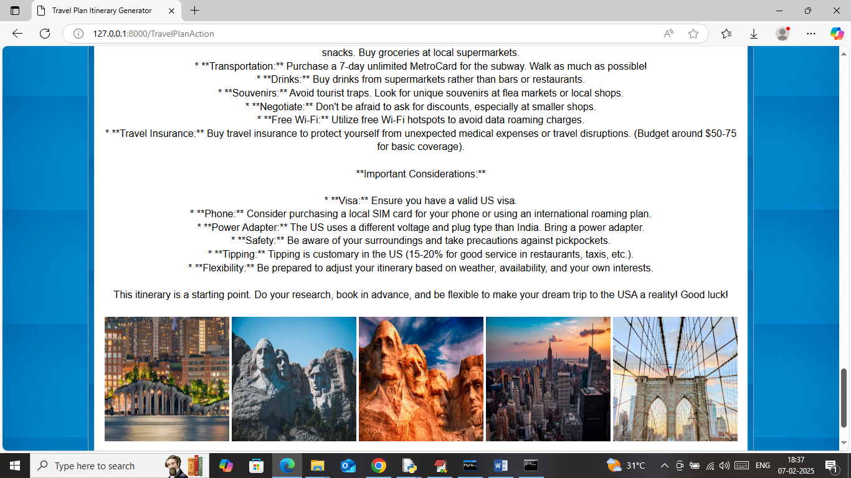

In above screen we can see entire travel plan generated from India to USA along with some web scrape images. Similarly you can scrape for any location and below is another plan

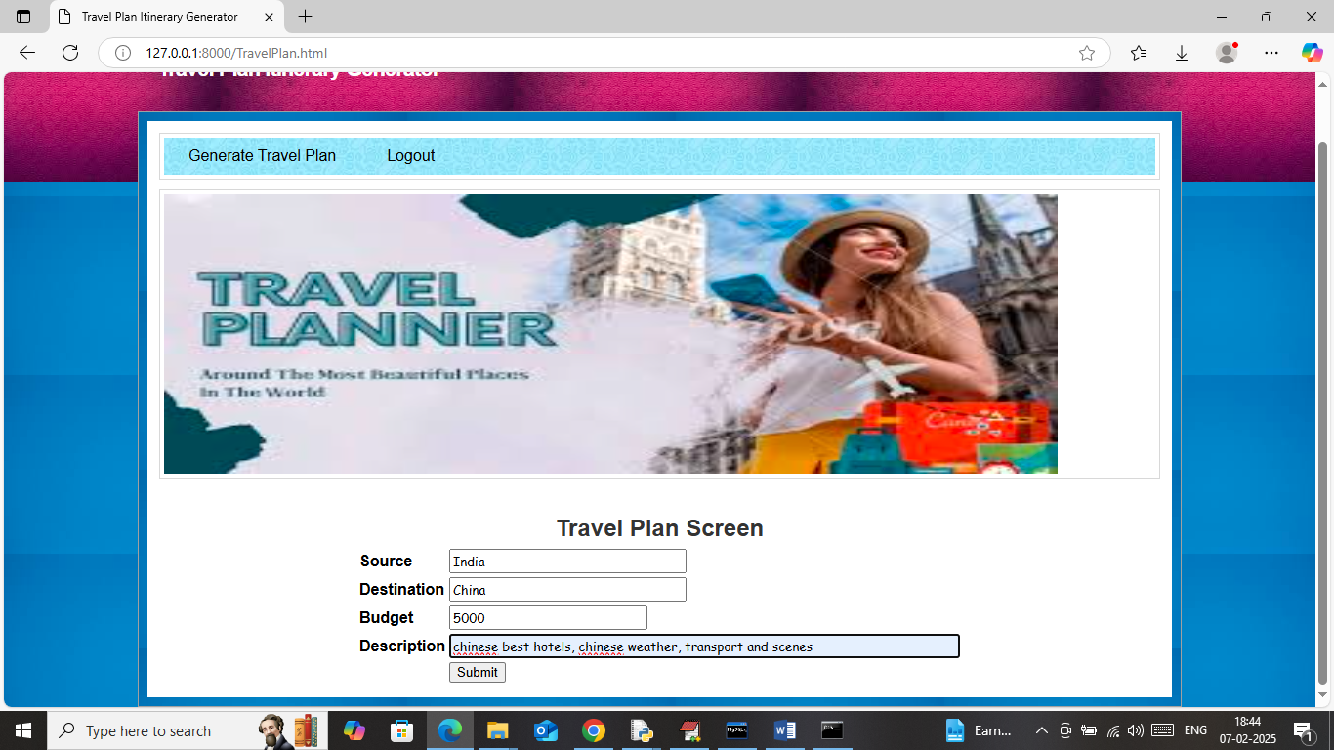

In above screen I am searching to create tour plan for China and below is the output

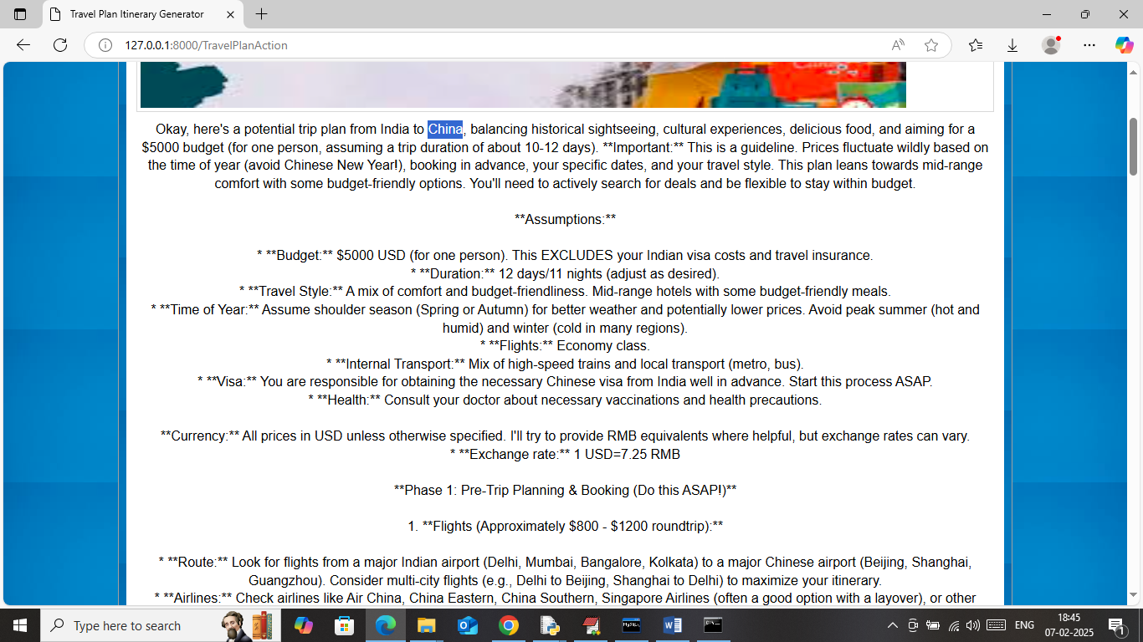

In above screen can see detailed tour plan created for CHINA and below is further description

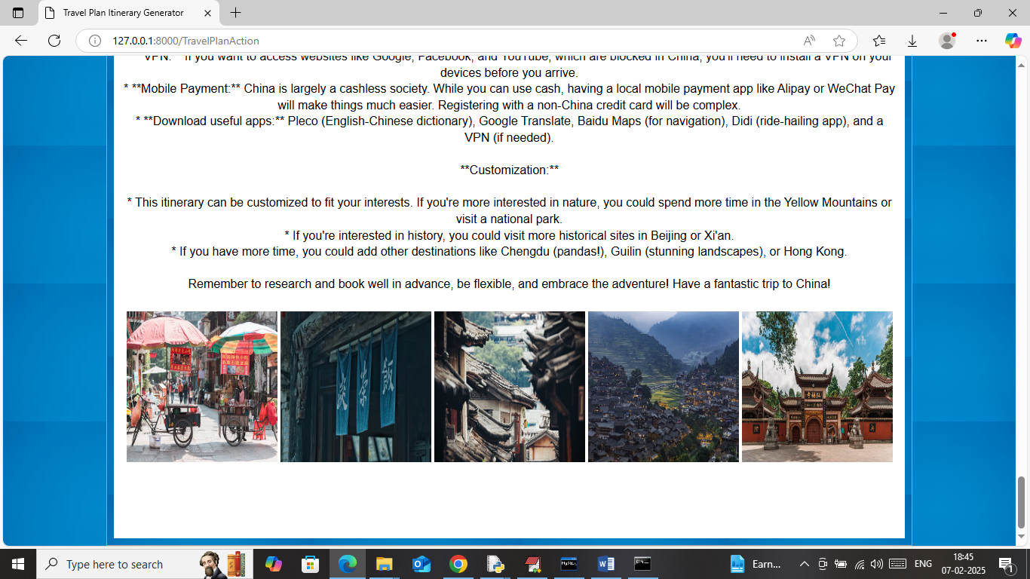

So in above screen can see some Chinese location images downloaded via scrape.

Now searching for Switzerland

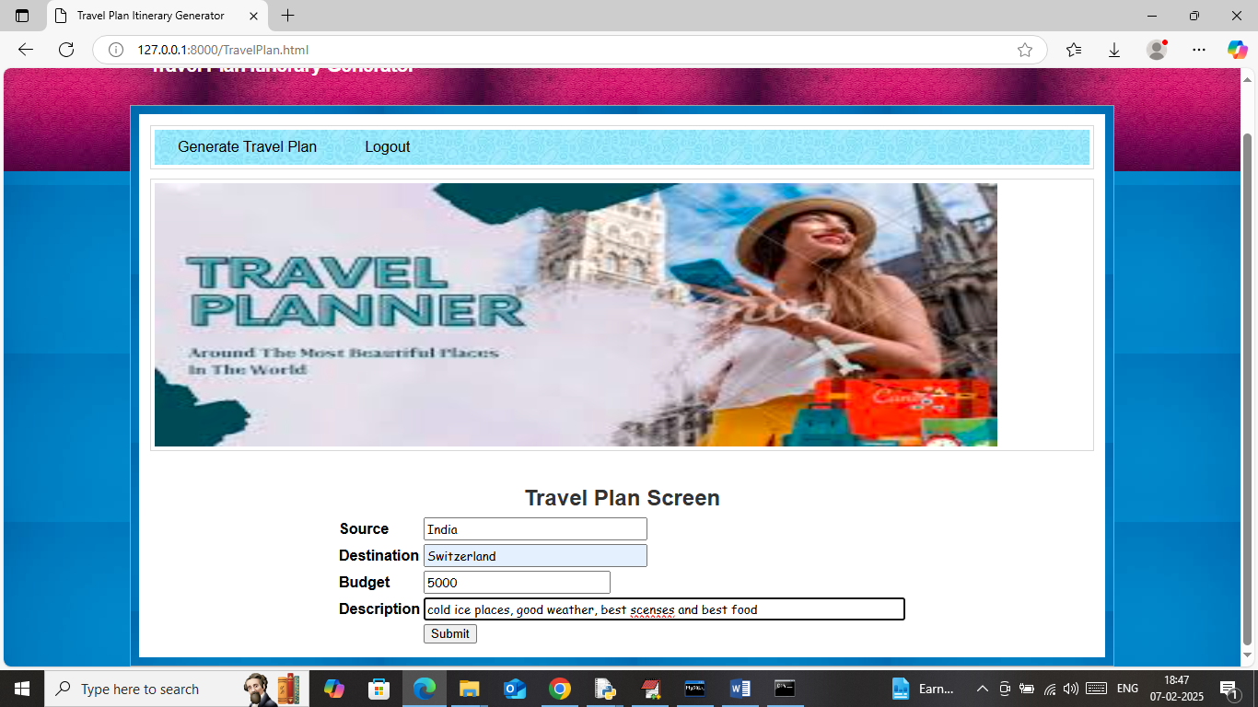

In above screen searching for Switzerland and below is the output

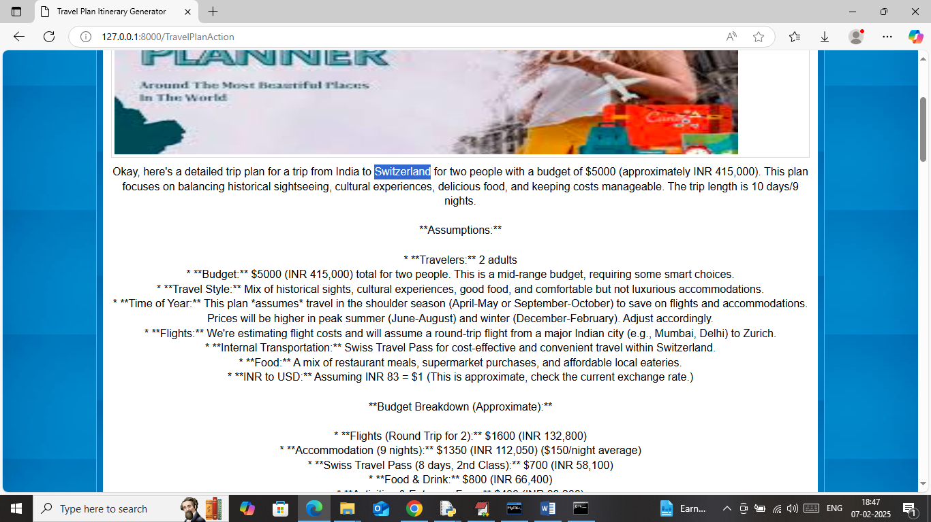

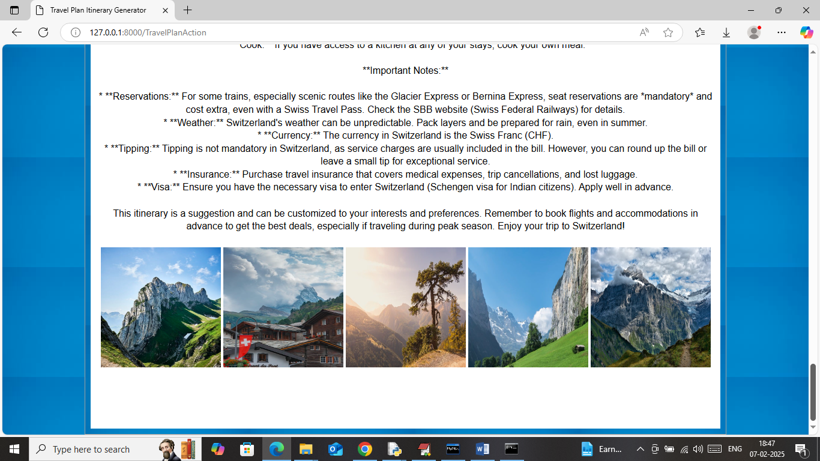

In above screen images downloaded from Switzerland places.

Similarly create plan for any places.